We are a custom manufacturer with the ability to fabricate just about any door and drawer profile or style required.

[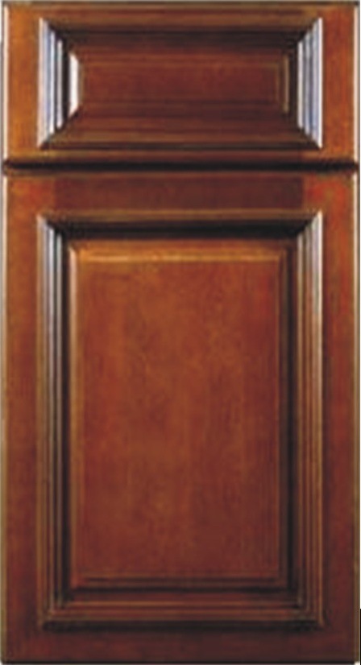](http://pridemaxx.com/cab1.html) [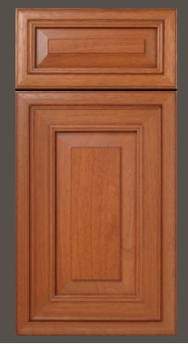](http://pridemaxx.com/cab2.html) [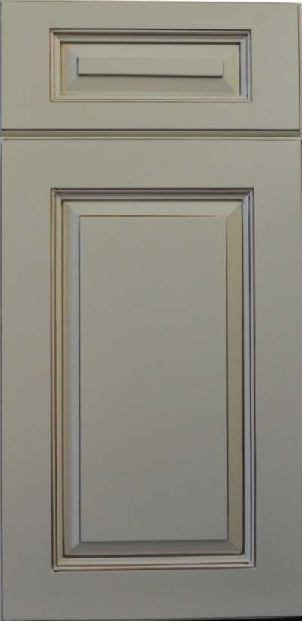](http://pridemaxx.com/VL.jpg) [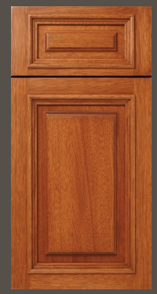](http://pridemaxx.com/cab5.html) [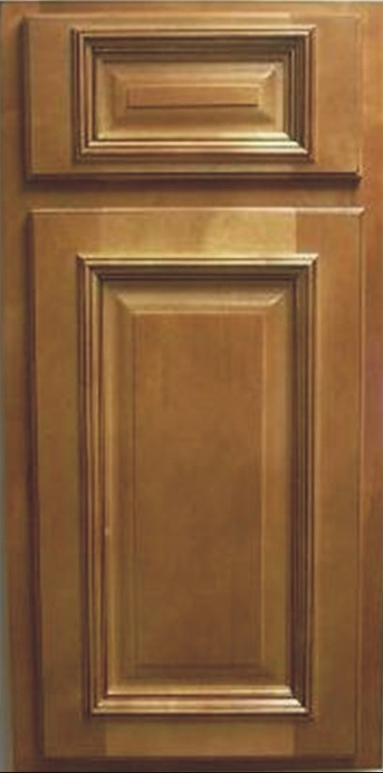](http://pridemaxx.com/cab4.html) [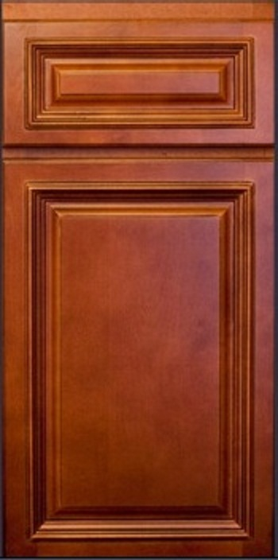](http://pridemaxx.com/cab9.html) [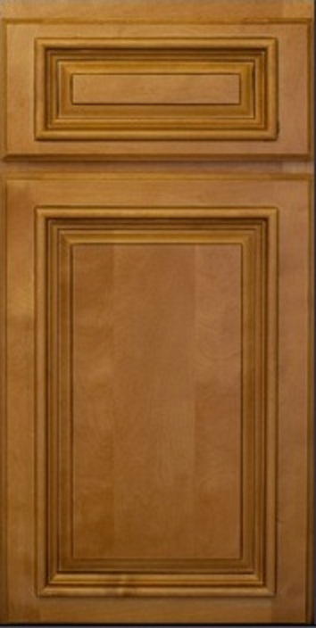](http://pridemaxx.com/cab10.html) [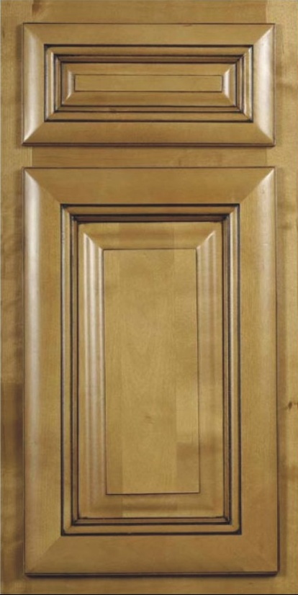](http://pridemaxx.com/cab6.html) [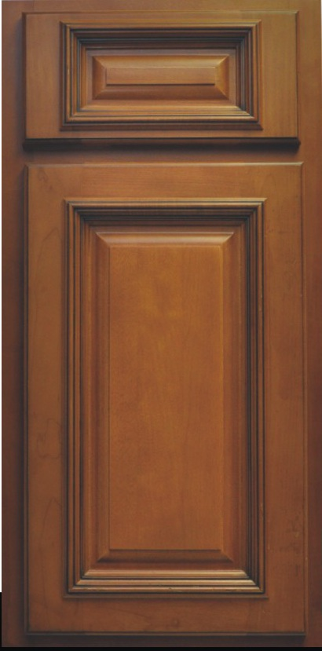](http://pridemaxx.com/cab7.html) 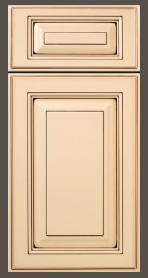 [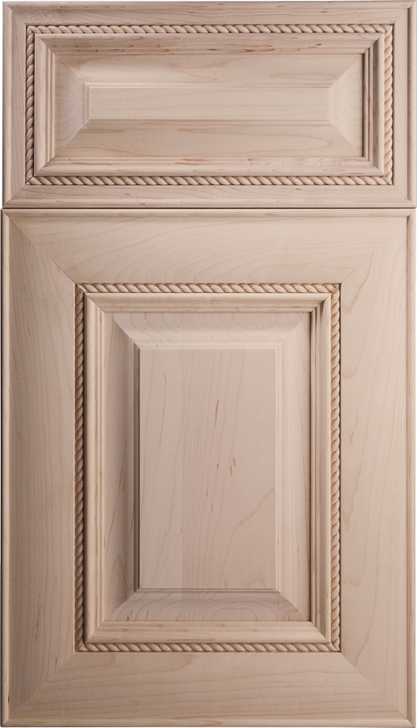 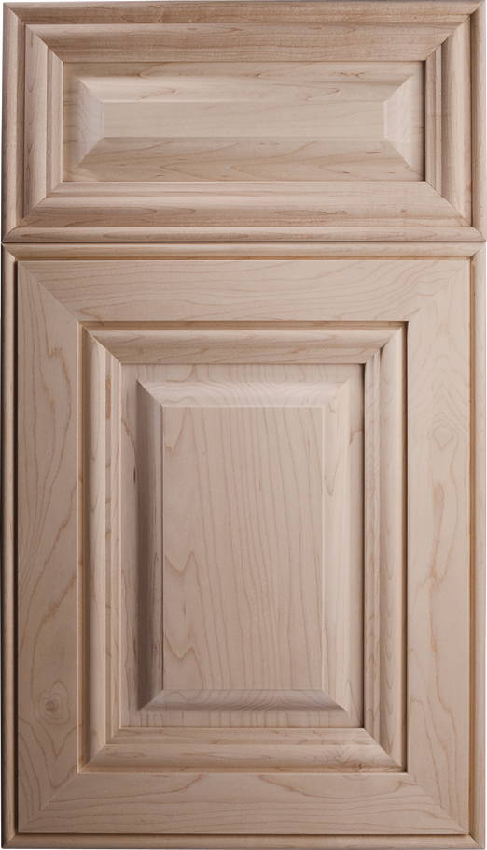 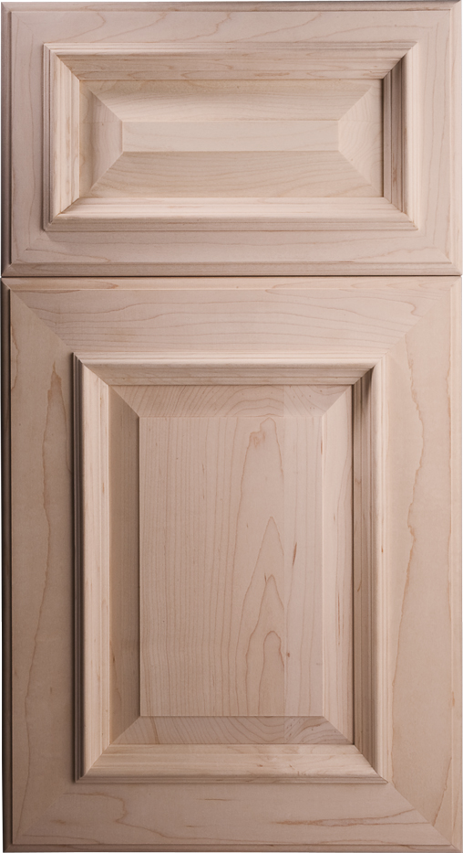](http://pridemaxx.com/images/New%20Doors/CD.jpg)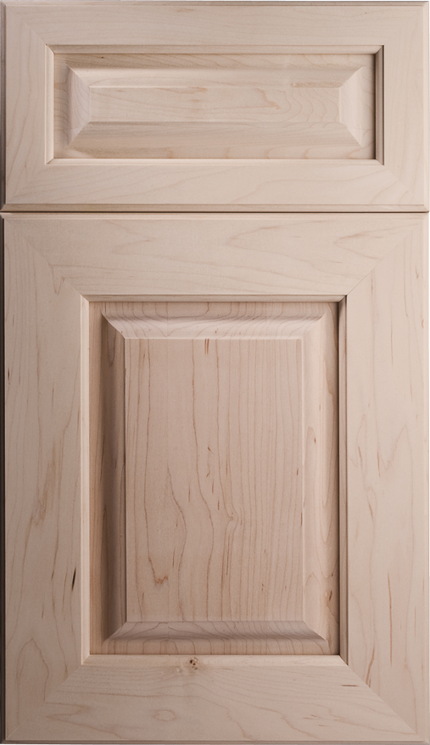 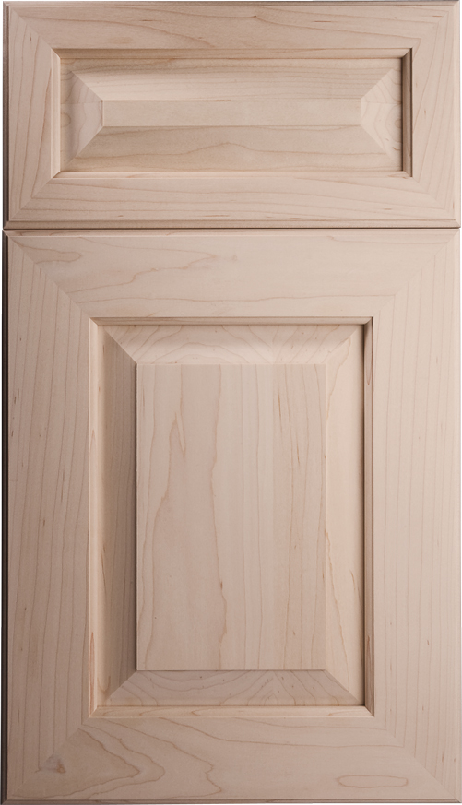 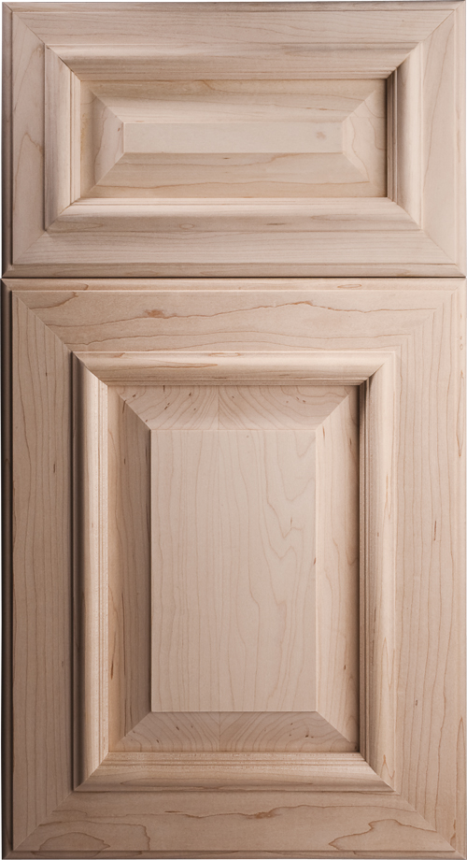 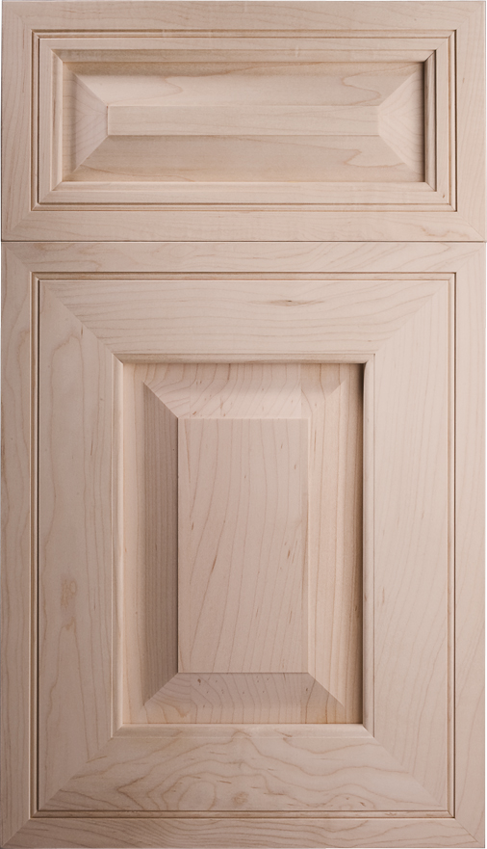 [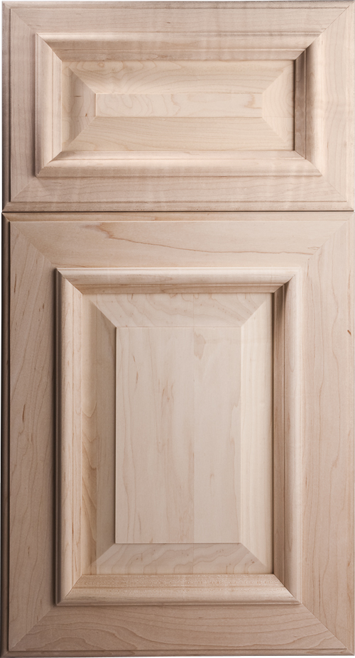](http://pridemaxx.com/images/New%2020Doors/s4.jpg) 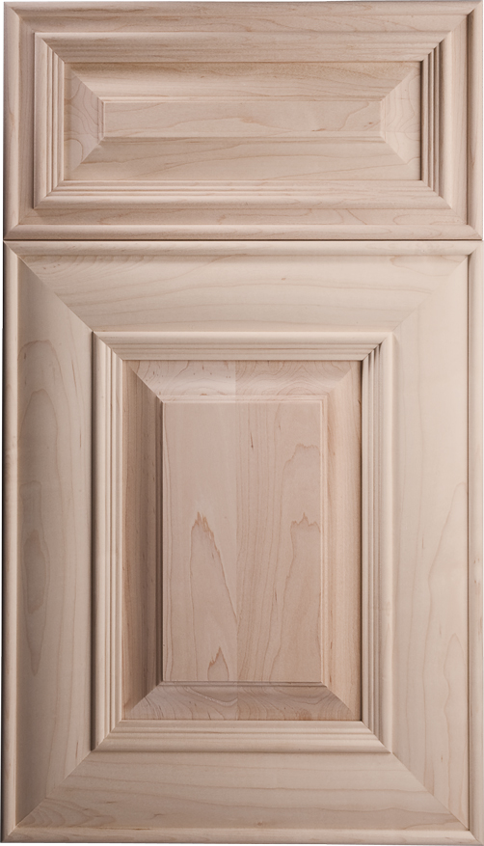 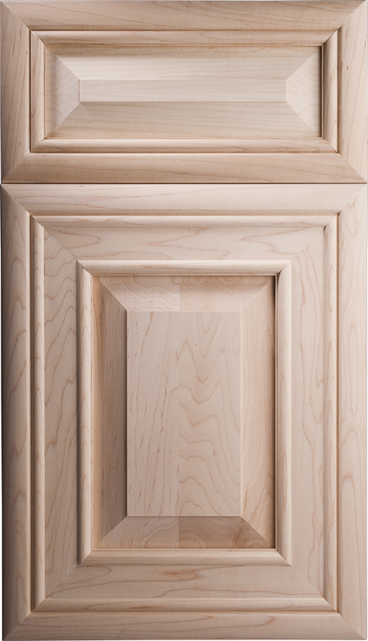 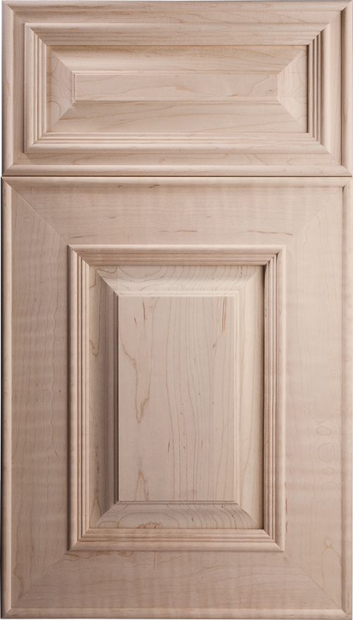 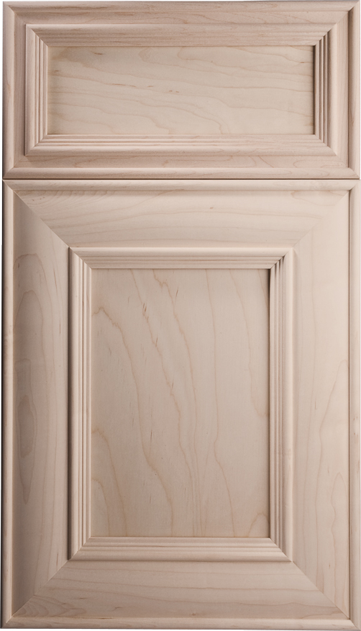 [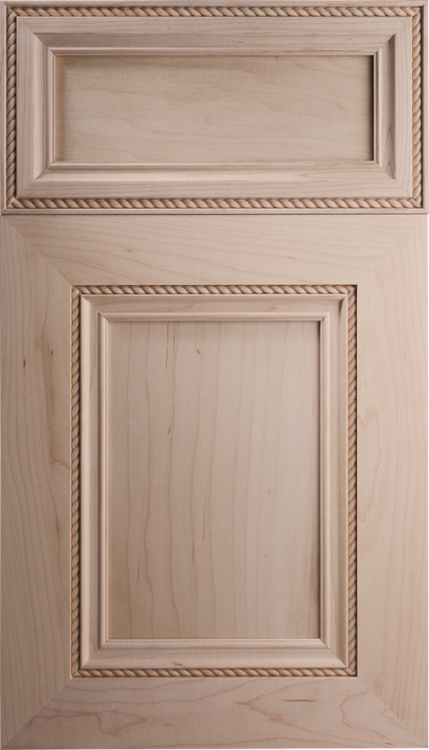](http://pridemaxx.com/images/New%20Doors/CN.jpg) [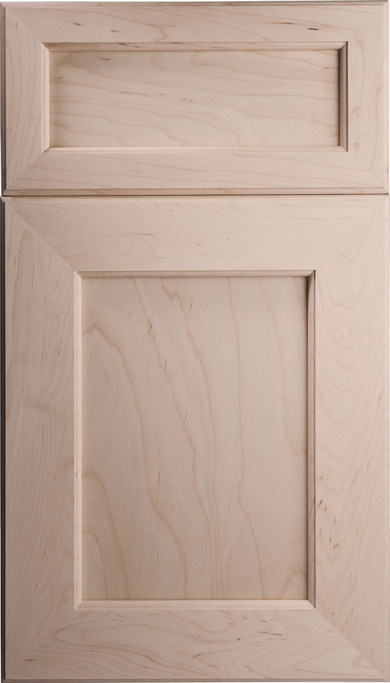 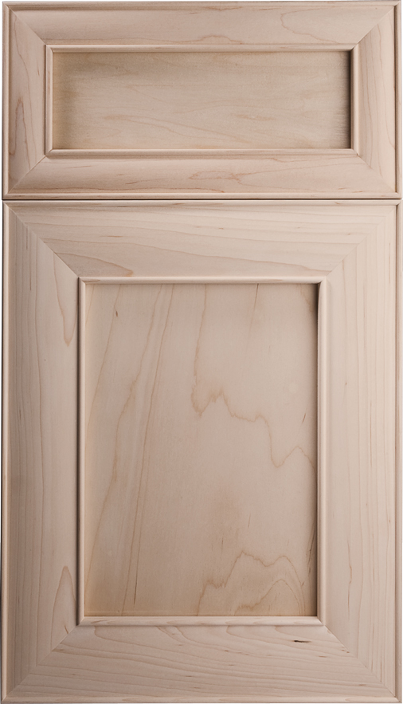 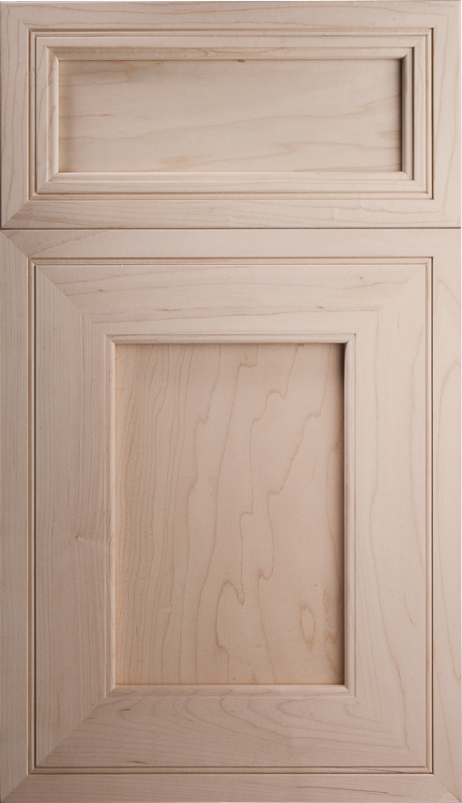 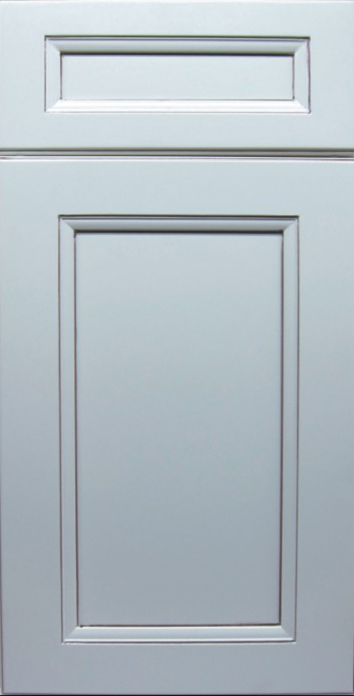](http://pridemaxx.com/images/New%20Doors/MN.jpg) [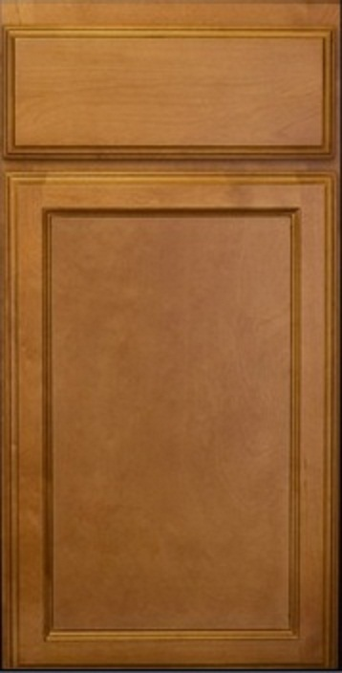 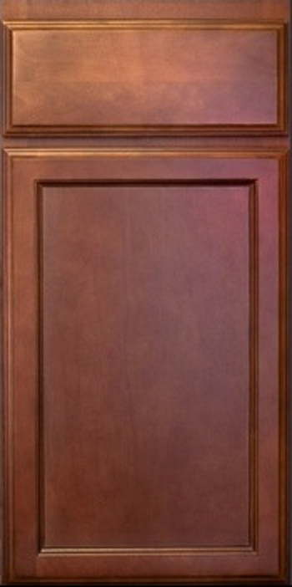 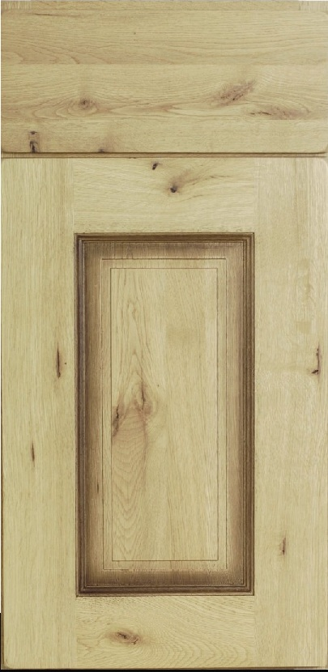](http://pridemaxx.com/images/New%20Doors/AE.jpg) [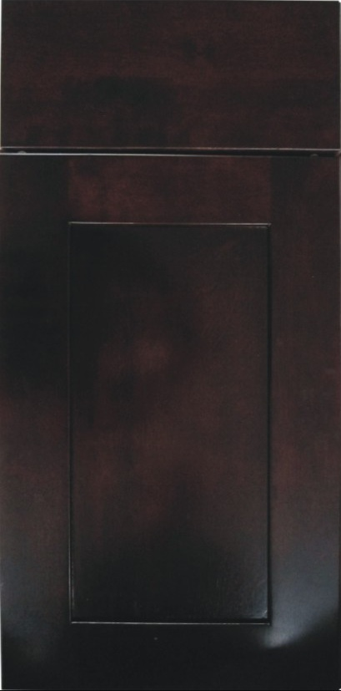](http://pridemaxx.com/images/New%20Doors/CL.jpg) [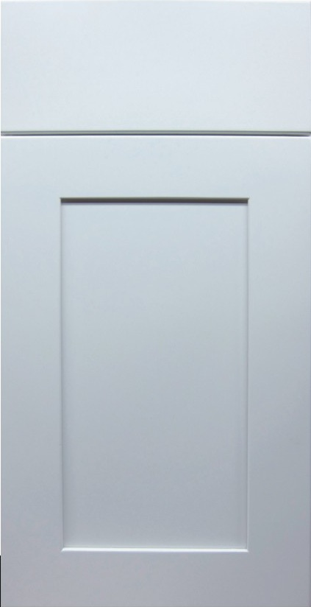](http://pridemaxx.com/images/New%20Doors/HE.jpg) [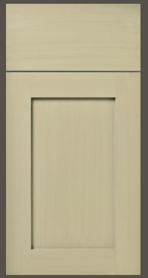](http://pridemaxx.com/images/New%20Doors/AN.jpg) [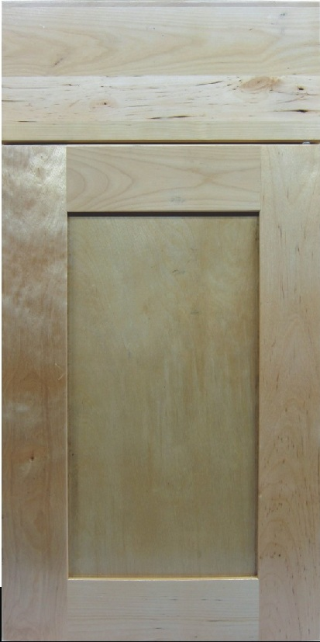](http://pridemaxx.com/images/New%20Doors/BN.jpg) [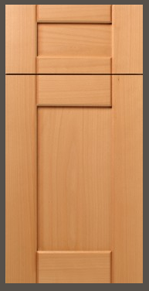](http://pridemaxx.com/images/New%20Doors/BART.jpg) [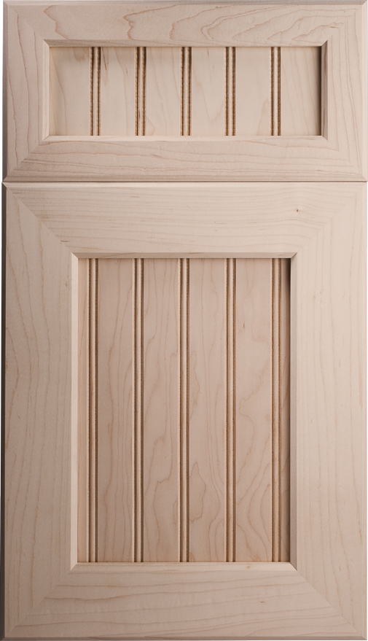 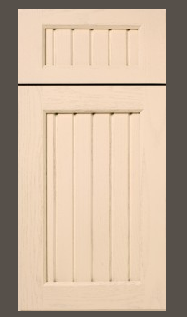](http://pridemaxx.com/images/New%20Doors/s1.jpg) [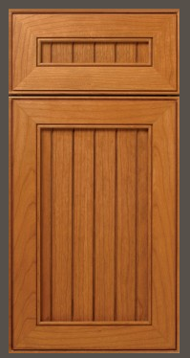](http://pridemaxx.com/images/New%20Doors/s2.jpg) [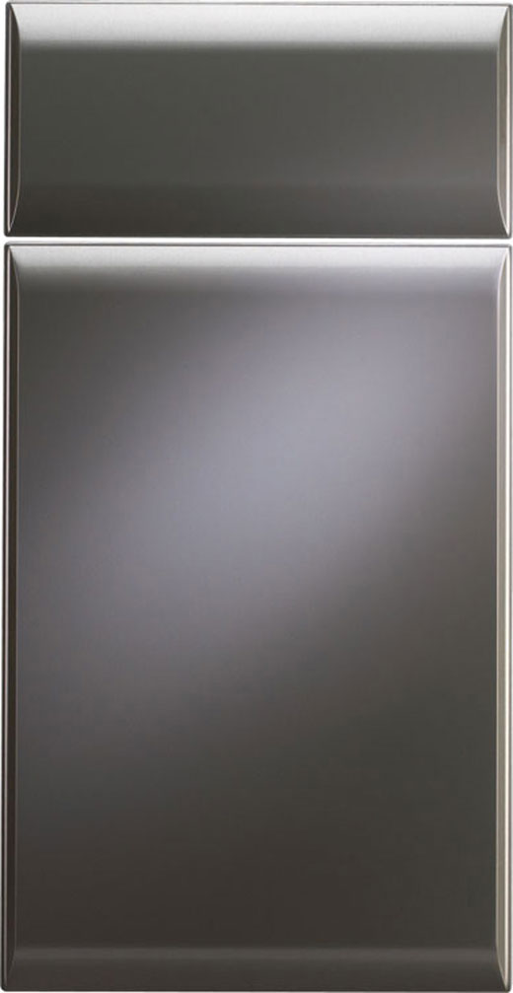](http://pridemaxx.com/images/New%20Doors/s3.jpg) [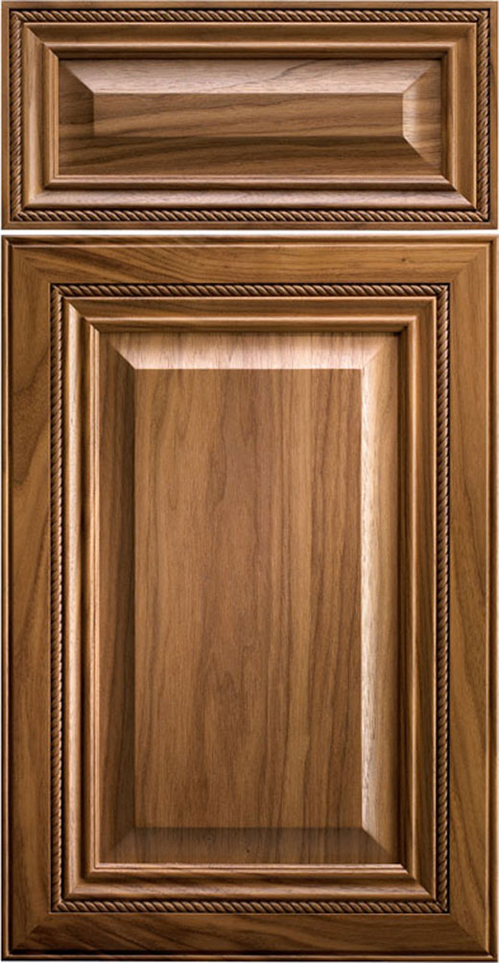](http://pridemaxx.com/images/New%20Doors/conpul.jpg) [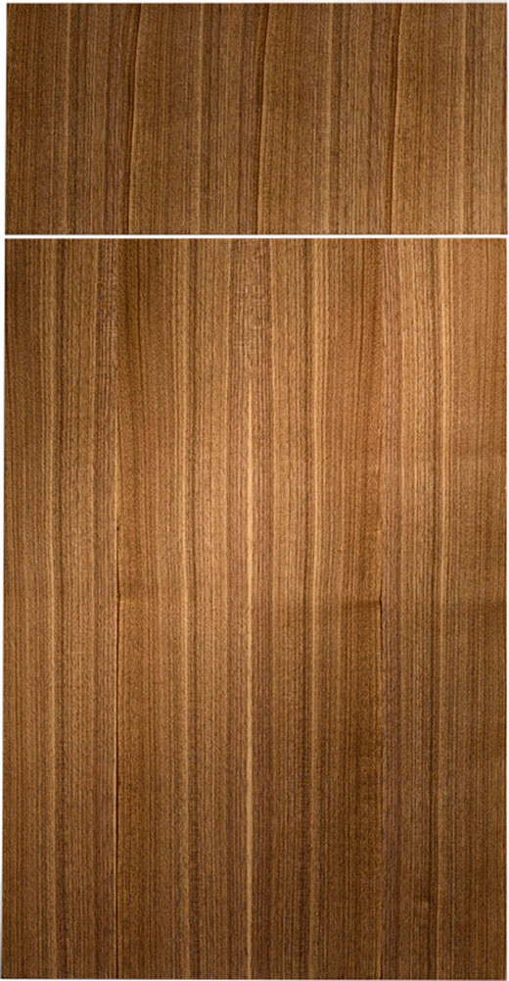](http://pridemaxx.com/images/New%20Doors/APM300M07P001.jpg) [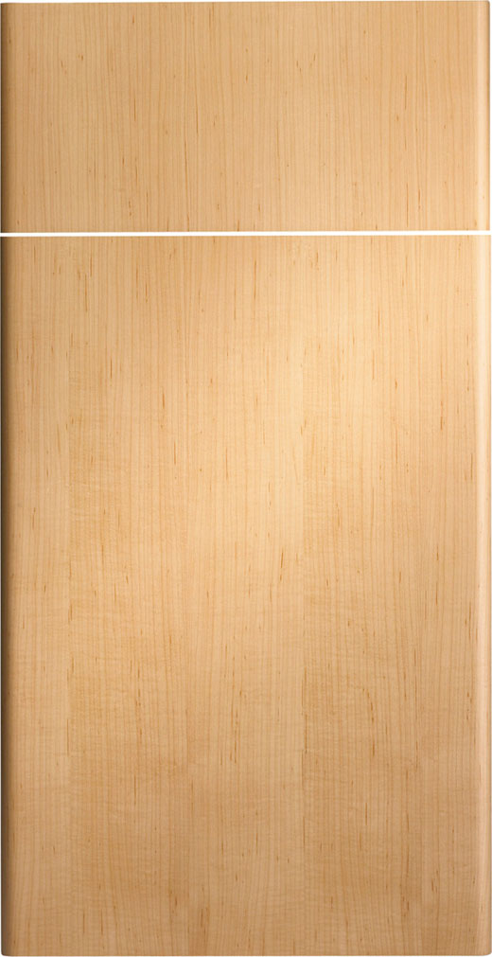](http://pridemaxx.com/images/New%20Doors/SPEMET.jpg) [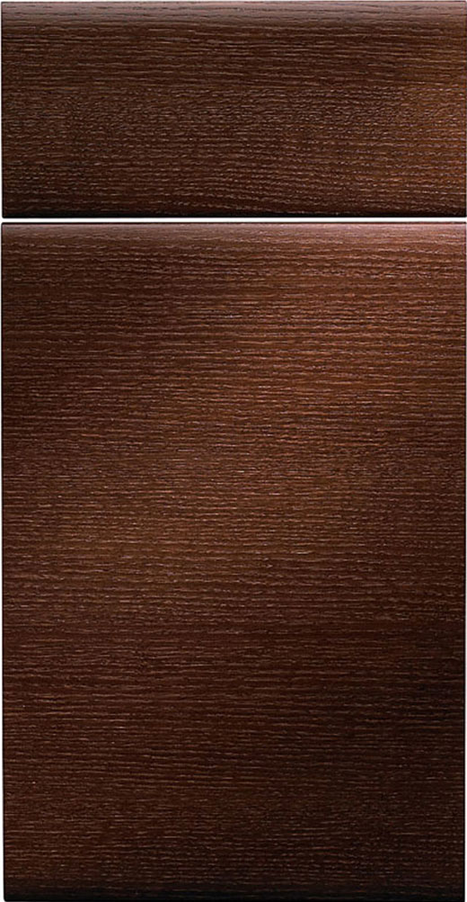](http://pridemaxx.com/images/New%20Doors/SPECOV.jpg) [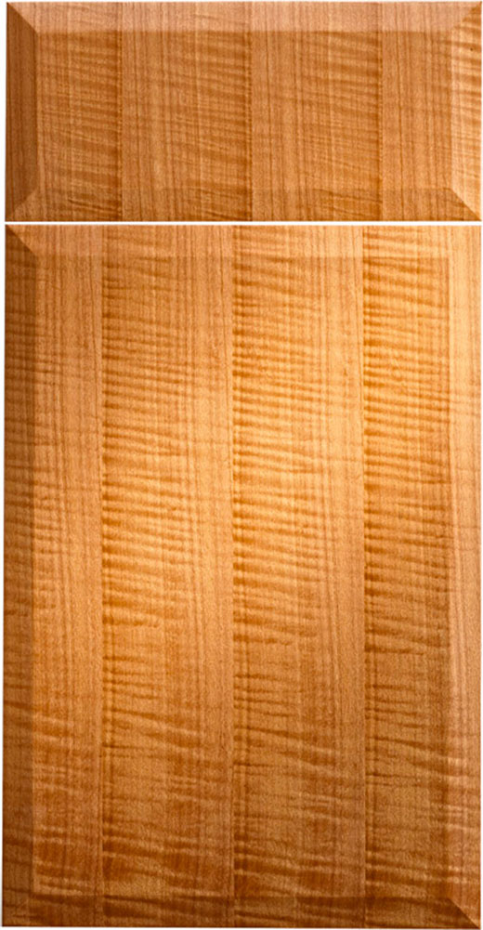](http://pridemaxx.com/images/New%20Doors/SPECON.jpg) [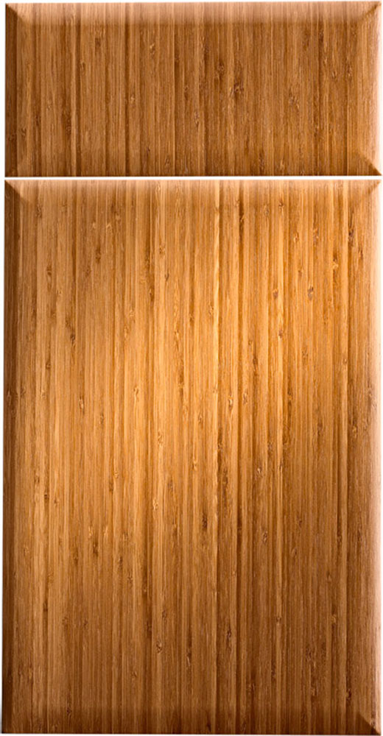](http://pridemaxx.com/images/New%20Doors/SPENOV.jpg) [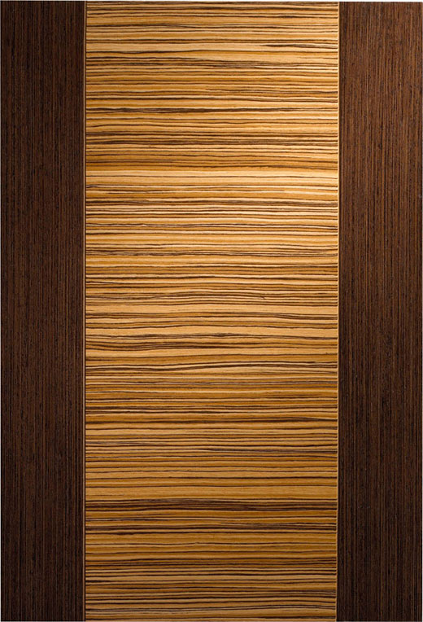](http://pridemaxx.com/images/New%20Doors/SPEFUS.jpg) [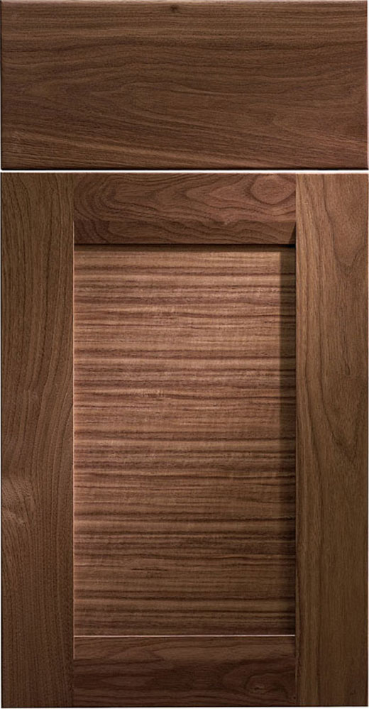](http://pridemaxx.com/images/New%20Doors/ELEWNG.jpg) [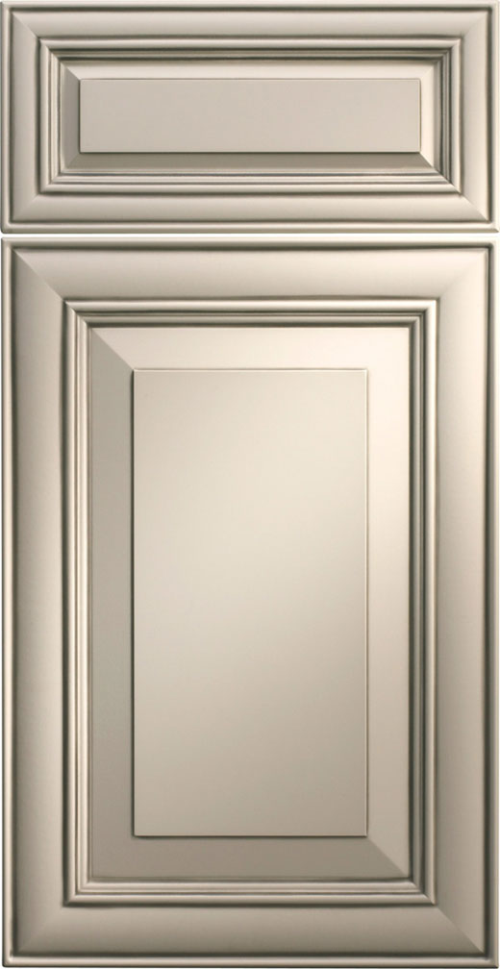](http://pridemaxx.com/images/New%20Doors/SHFDEG.jpg) [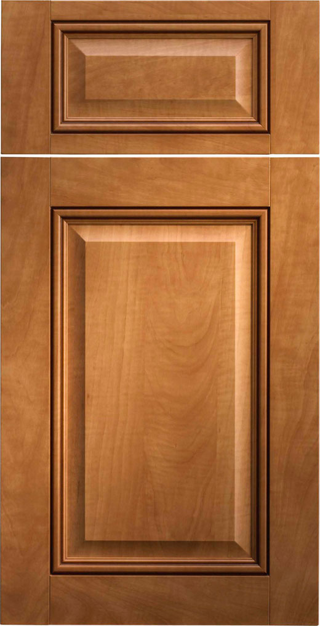](http://pridemaxx.com/images/New%20Doors/GLZMTH.jpg) [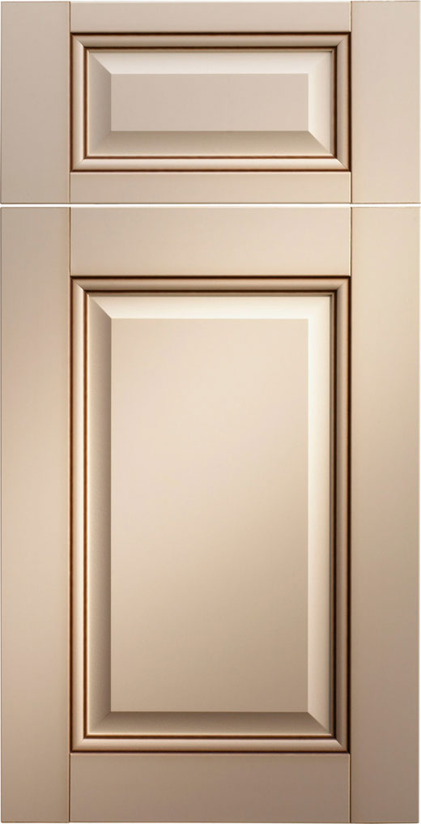](http://pridemaxx.com/images/New%20Doors/PFM30132078.jpg) [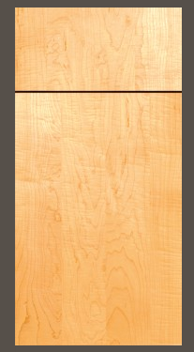](http://pridemaxx.com/images/New%20Doors/PFM30030150.jpg) [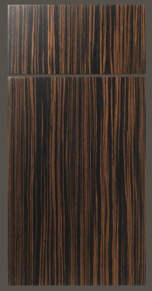](http://pridemaxx.com/images/New%20Doors/s4.jpg)

1034